1 | Principio del formulario
  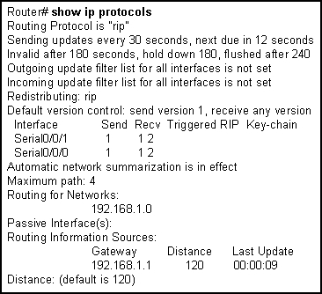
  Refer to the exhibit. A network consists of multiple routers. What can be verified when the show ip protocols command is issued on one of the routers in the network?
   | whether all routes in the network have been properly added to the routing table
   | routing protocol configuration in use for IP on this router
   | operational status of routing protocols in use on all routers in the network
   | routing metric of each network that is listed in the routing table
2 | Principio del formulario
  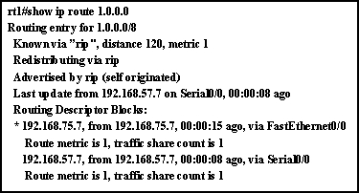
  Refer to the output from the show ip route command. What can be concluded from the output of this router command?
  A preferred route to the destination has not been set.
  There are two equal cost paths to network 1.0.0.0.
  Both interfaces are being used equally to route traffic.
  A variance must be set to load-balance across multiple paths.

3 | Principio del formulario
  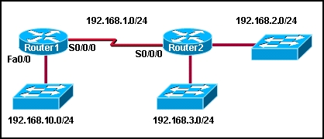
  Refer to the exhibit. The network that is shown is running RIPv1. The 192.168.10.0/24 network was recently added and will only contain end users. What command or set of commands should be entered on Router1 to prevent RIPv1 updates from being sent to the end user devices on the new network while still allowing this new network to be advertised to other routers?
  Router1(config-router)# no router rip
  Router1(config-router)# network 192.168.10.0
  Router1(config-router)# no network 192.168.10.0
  Router1(config-router)# passive-interface fastethernet 0/0
  Router1(config-router)# passive-interface serial 0/0/0
4 | Principio del formulario
  What will happen if an interface IP address is entered for the address portion of the network command in a RIPv1 configuration instead of a network address?
  The router will reject the command.
  A route to the host address will be added to outgoing RIP updates.
  A route to the host address will be added to the routing table.
  All interfaces in the same classful network as the configured address will be included in the RIPv1 routing process.

5 | Principio del formulario
  Which command or set of commands will stop the RIP routing process?
  RouterB(config)# router rip
  RouterB(config-router)# shutdown
  RouterB(config)# router rip
  RouterB(config-router)# network no 192.168.2.0
  RouterB(config)# no router rip
  RouterB(config)# router no rip
6 | Principio del formulario
  Which two statements are true regarding the characteristics of RIPv1? (Choose two).
   | It is a distance vector routing protocol.
   | It advertises the address and subnet mask for routes in routing updates.
   | The data portion of a RIP message is encapsulated into a TCP segment.
   | The data portion of a RIP message is encapsulated into a UDP segment.
   | It broadcasts updates every 15 seconds.
   | It allows a maximum of 15 routers in the routing domain.

7 | Principio del formulario
  Which command will display RIP activity as it occurs on a router?
  debug ip rip
  show ip route
  show ip interface
  show ip protocols
  debug ip rip config
  show ip rip database
8 | Principio del formulario
  The following line was displayed in the output of the show ip route command.
  R 192.168.3.0/24 [120/3] via 192.168.2.2, 00:00:30, Serial0/0
  What is the value of the routing metric?
  3
  12
  20
  30
  120

9 | Principio del formulario
  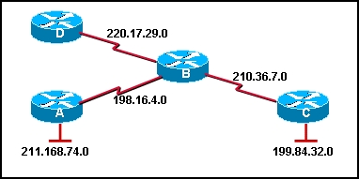
  Which of the following would be the correct command sequence to enable RIP on Router B for all connected networks?
  RouterB# router rip
  RouterB(router)# network 210.36.7.0
  RouterB(router)# network 220.17.29.0
  RouterB(router)# network 211.168.74.0
  RouterB(config)# router rip
  RouterB(config-router)# network 198.16.4.0
  RouterB(config-router)# network 211.168.74.0
  RouterB(config-router)# network 199.84.32.0
  RouterB(config)# configure router rip
  RouterB(config-router)# network 210.36.7.0
  RouterB(config-router)# network 199.84.32.0
  RouterB(config-router)# network 211.168.74.0
  RouterB(config)# router rip
  RouterB(config-router)# network 198.16.4.0
  RouterB(config-router)# network 210.36.7.0
  RouterB(config-router)# network 211.168.74.0
  RouterB(config)# router rip
  RouterB(config-router)# network 198.16.4.0
  RouterB(config-router)# network 210.36.7.0
  RouterB(config-router)# network 220.17.29.0
10 | Principio del formulario
  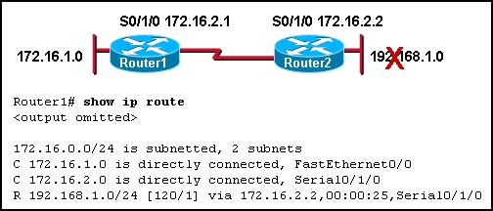
  Refer to the exhibit. The Ethernet interface on Router2 goes down and the administrator notices that the route is still in the Router1 routing table. How much longer will Router1 keep the down network in its routing table before marking it as possibly down?
  30 seconds
  90 seconds
  155 seconds
  180 seconds
  255 seconds

11 | Principio del formulario
  Which of the following is considered a limitation of RIP v1?
  RIP v1 does not send subnet mask information in its updates.
  RIP v1 is not widely supported by networking hardware vendors.
  RIP v1 consumes excessive bandwidth by multicasting routing updates using a Class D address.
  RIP v1 requires enhanced router processors and extra RAM to function effectively.
  RIP v1 does not support load balancing across equal-cost paths.
  RIP v1 authentication is complicated and time-consuming to configure.
12 | Principio del formulario
  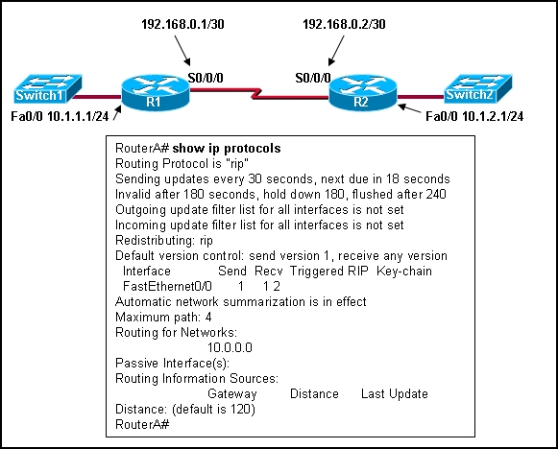
  Refer to the exhibit. Pings between the serial interfaces of the routers are successful. Hosts on each LAN can ping the Fa0/0 interface of the router to which they are directly connected through the switch. However, pings between hosts on the 10.1.1.0/24 and 10.1.2.0/24 networks are unsuccessful. What is a likely cause of this problem?
  The Fa0/0 interface on R1 is configured as a passive interface.
  The Fa0/0 interfaces on each router is shutdown.
  RIP is configured incorrectly on R1.
  Automatic summarization is preventing the routing updates from being forwarded.
  The network has not converged and R2 must wait 12 more seconds before receiving a full routing table update from R1.

13 | Principio del formulario
  What are three characteristics of the RIPv1 routing protocol? (Choose three.)
  supports the use of VLSM
  uses hop count as a metric
  considers a metric of 16 as infinity
  has an administrative distance of 110 by default
  includes the destination IP address and subnet mask in routing updates
  calculates metrics using the Bellman Ford algorithm
14 | Principio del formulario
  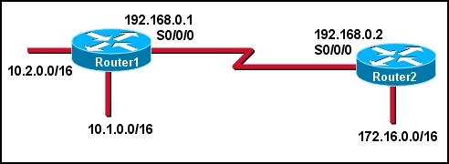
  Refer to the exhibit. Router1 and Router2 are running the RIPv1 protocol. The network administrator configures the command network 10.1.0.0 on Router1. What network will Router1 advertise to Router2?
  10.1.0.0/16
  10.1.0.0/8
  10.0.0.0/16
  10.0.0.0/8

15 | Principio del formulario
  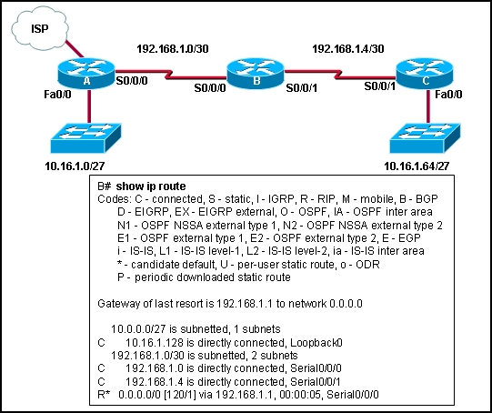
  Refer to the exhibit. What can be concluded from the routing table output of router B?
  A static default route has been configured on B.
  The default-information originate command has been entered on A.
  All traffic that is destined for 192.168.1.1 will be sent to address 0.0.0.0.
  Hosts on the 10.16.1.0/27 network have 192.168.1.1 configured as the default gateway address.
16 | Principio del formulario
  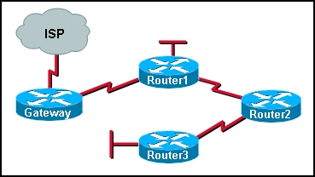
  Refer to the exhibit. All routers that are shown are running the RIP routing protocol. All unknown IP traffic must be forwarded to the ISP. What router or set of routers are recommended to have both a default route and the default-information originate command issued to implement this forwarding policy?
  only Router1
  only the gateway router
  all routers in the network
  only the routers with LANs needing Internet access
17 | Principio del formulario
  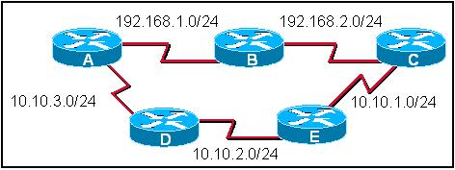
  Refer to the exhibit. All routers in the exhibit are running RIP v1. The network administrator issues the show ip route command on router A. What routes would appear in the routing table output if the network is converged? (Choose two).
  R 192.168.2.0/24 [120/1]
  C 192.168.2.0/24 [120/1]
  R 10.10.3.0/24 [120/0]
  C 10.10.3.0/24 [120/1]
  R 10.10.1.0/24 [120/2]
  R 10.10.1.0/24 [120/3]

18 | Principio del formulario
  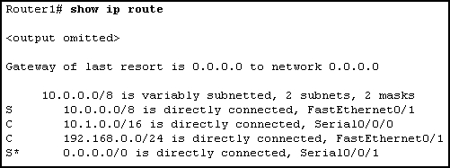
  Refer to the exhibit. Router1 is running RIPv1. What command was entered into Router1 to configure the gateway of last resort?
  no auto-summary
  ip default-network 0.0.0.0
  ip default-gateway 10.0.0.0
  ip route 0.0.0.0 0.0.0.0 S0/0/1
19 | Principio del formulario
  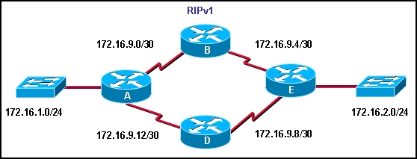
  Refer to the exhibit. All routers are configured with valid interface addresses in the indicated networks and are running RIPv1. The network is converged. Which routes are present in the routing tables?
  All routers have all routes in their routing table.
  All routers have all /30 routes, but do not have /24 routes in their routing table.
  All routers have all /30 routes. Routers A and E also have some of the /24 routes in their routing table.
  All routers have all /30 routes. Routers B and D also have some of the /24 routes in their routing table.
  Routers A and E have all routes. Routers B and D have only /30 routes in their routing table.
  Routers A and E have only /24 routes. Routers B and D have only /30 routes in their routing table.

20 | Principio del formulario
  What is the default update period in seconds for the RIP routing protocol?
  10
  12
  15
  20
  30
  60

